Making an accessible PDF starts with the document before it’s converted to PDF. Whether you decide to make available the Word file or a PDF, you should create an accessible document beginning with the creation of the Word file by:

- Creating Heading styles, true headings and subheadings (Heading 1, 2, 3, etc.), not just bolded, enlarged or centered text. People using screen readers can navigate through the document using these heading styles.
- Creating true bulleted or numbered lists.
- Adding alt text to images.
  - Right click the image, select Format Picture (or select Format > Picture from the menu bar), click the Web tab and enter the description in the box labeled Alternative text.
- Creating charts and tables by:
  - Using the table feature in Microsoft Word (Table > Insert > Table) rather than by using the tab key or spacebar to position text on the page.
  - Creating row headers across the top of the page by setting the row as a header. Select the table and choose Table > Table Properties > Row tab > Repeat as Header Row at the top of each page. (This only works if the chart or table has one header row. For tables with more than one row of headers, or if it has a set of column headers, it is not possible to add proper headings.)
- Ensuring sufficient color contrast in text, charts and images.
  - One way to verify this is to print out the document on a black and white printer.
- Using a column layout if you have two or more columns of information. Use Format > Columns, to lay out the columns. Don't use spaces, tabs, or the table feature to simulate multicolumn text.
- Making sure that form elements have text descriptions. Verify that the form can be completed using the keyboard.

Converting Word to PDF

- From the MS Word version, run a Spelling and Grammar check from the Tools menu. This removes all unwanted red and green error notations from the document then SAVE.
- From the File tab go to Properties.
- In the Properties pane type in TCEQ - , then the Title of the document, and copy/paste the Title into the Subject area.
- Include TCEQ as the Author and Company.
- Type or copy/paste in Keywords, click OK, and then SAVE.

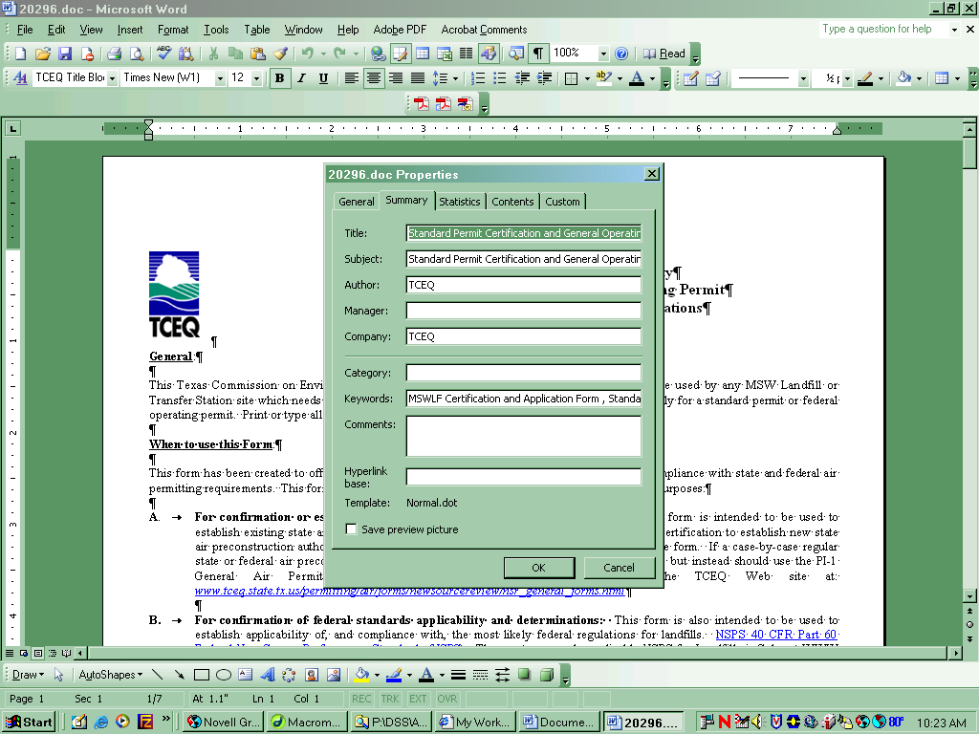

- In MS Word go to Adobe PDF > Change Conversion Settings > then uncheck Enable accessibility and reflow Tagged PDF. Then choose OK.

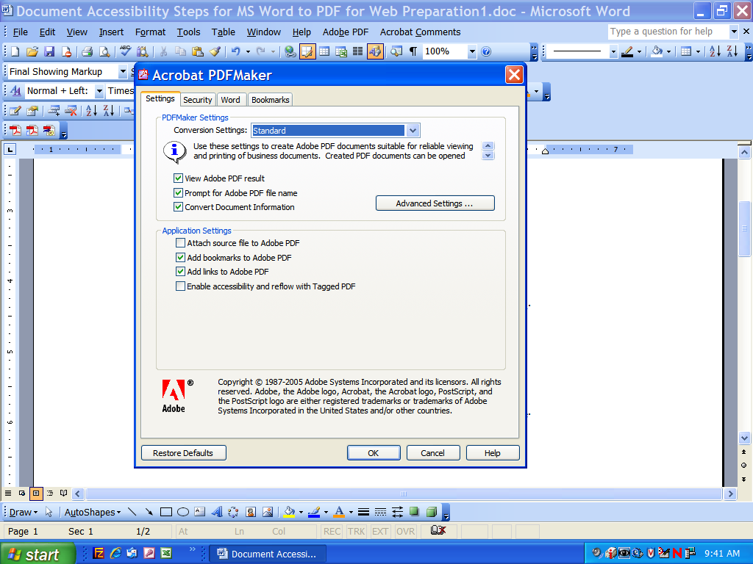

- Next choose the “Convert to PDF” icon or tab.
- Once PDF conversion is complete go to File > Document Properties from the Adobe Acrobat PDF version. You may close the MS Word version at this point.
- From the PDF Document Properties pane, Description tab, you should see the Title, Subject, Author and Keywords have transferred over. Click OK.

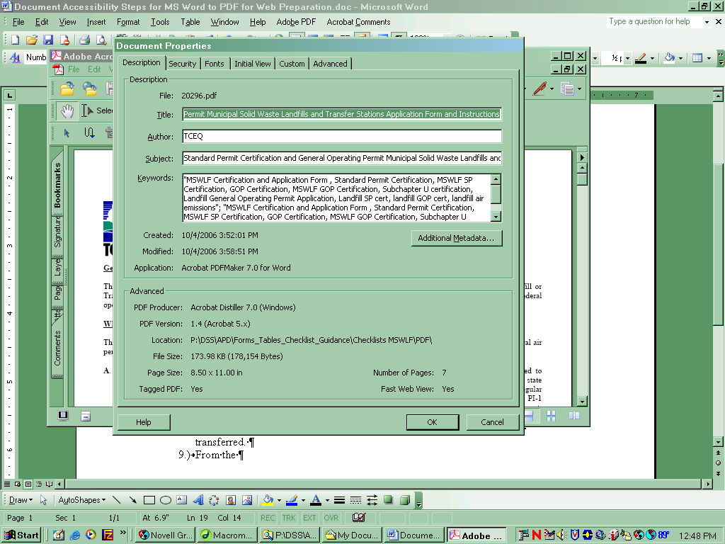

- If your PDF document is a form, proceed to field creation, otherwise your document is ready.
  - When creating form fields, be sure to complete a Tool Tip and follow your form field creation standards.
  - Once your form fields are complete, set Tab Order, and proceed to Tagging.
- Go to Advanced > Accessibility > Add Tags to Document.

- Go to File > Document Properties. Choose the Advanced tab then choose
English from the Language drop down menu. Then click OK.
- Go to Advanced > Accessibility >Full Check. Click Start Checking.
- The checker will display the result of the Full Check and an Accessibility Report panel will open with information to assist in correcting any issues found. Correct any issues reported and Save the document. Run the Full Check until the checker finds no problems in the document.

Common PDF Accessibility Errors

After running the Adobe Accessibility Full Check, Adobe opens a report pane including possible errors and how to correct them. Below are the most common errors.

Missing Alt Tags
- From the report pane, click on No alternate text, this will highlight the image/item in question.
- Then go to Advanced > Accessibility > choose Touchup Reading Order. This will open the touchup reading order pane.
- Using the cross hair curser, drag the curser around the item.
- Now choose the appropriate button, best describing the item.
- With curser over item, right click and choose Edit Alternate Text.
- In the dialog box type your description. Then choose OK and SAVE.
- Repeat 5 – 6 for all items requiring Alternate Text.

Tab Order
If the report states you have items that may not be in the structure tree, complete the following to reset your Tab Order for each page in the document:

- To set the tab order for links, form fields, comments, and other annotations, click the Pages tab in the navigation pane.
- Select a page thumbnail and choose Page Properties from the Options menu.
- In the Page Properties dialog, click Tab Order and select Use Document Structure.
- Repeat the steps for all pages in the document.

Validation with a Screen Reader
The last step to ensuring accessibility is to validate the PDF document using a screen reader.

Using Acrobat Adobe Screen Reader
A screen reader is available in Acrobat Adobe Professional. To hear the PDF document go to View > Read Out Loud and choose Read This Page Only or Read to End of Document.

